Semester One Examination, 2017

Question/Answer booklet

MATHEMATICS

SOLUTIONS
METHODS
UNIT 1

Section One:

Calculator-free

Student Number: In figures

In words

Your name

Time allowed for this section
Reading time before commencing work: five minutes
Working time: fifty minutes

Materials required/recommended for this section
To be provided by the supervisor
This Question/Answer booklet
Formula sheet

To be provided by the candidate
Standard items: pens (blue/black preferred), pencils (including coloured), sharpener, correction fluid/tape, eraser, ruler, highlighters

Special items: nil

Important note to candidates
No other items may be taken into the examination room. It is your responsibility to ensure that you do not have any unauthorised material. If you have any unauthorised material with you, hand it to the supervisor before reading any further.

Structure of this paper

Section | Number of questions available | Number of questions to be answered | Working  time (minutes) | Marks available | Percentage of examination
Section One:  Calculator-free | 7 | 7 | 50 | 52 | 35
Section Two:  Calculator-assumed | 11 | 11 | 100 | 85 | 65
 |  |  |  | Total | 100

Instructions to candidates

1. The rules for the conduct of examinations are detailed in the school handbook. Sitting this examination implies that you agree to abide by these rules.

2. Write your answers in this Question/Answer booklet.

3. You must be careful to confine your response to the specific question asked and to follow any instructions that are specified to a particular question.

4. Additional working space pages at the end of this Question/Answer booklet are for planning or continuing an answer. If you use these pages, indicate at the original answer, the page number it is planned/continued on and write the question number being planned/continued on the additional working space page.

5. Show all your working clearly. Your working should be in sufficient detail to allow your answers to be checked readily and for marks to be awarded for reasoning. Incorrect answers given without supporting reasoning cannot be allocated any marks. For any question or part question worth more than two marks, valid working or justification is required to receive full marks. If you repeat any question, ensure that you cancel the answer you do not wish to have marked.

6. It is recommended that you do not use pencil, except in diagrams.

7. The Formula sheet is not to be handed in with your Question/Answer booklet.

Section One: Calculator-free 35% (52 Marks)
This section has seven (7) questions. Answer all questions. Write your answers in the spaces provided.

Working time: 50 minutes.

Question 1 (6 marks)
(a) On the axes below, sketch the graph of the relation $y^{2}=x$, labelling all key features with their coordinates or equations. (3 marks)

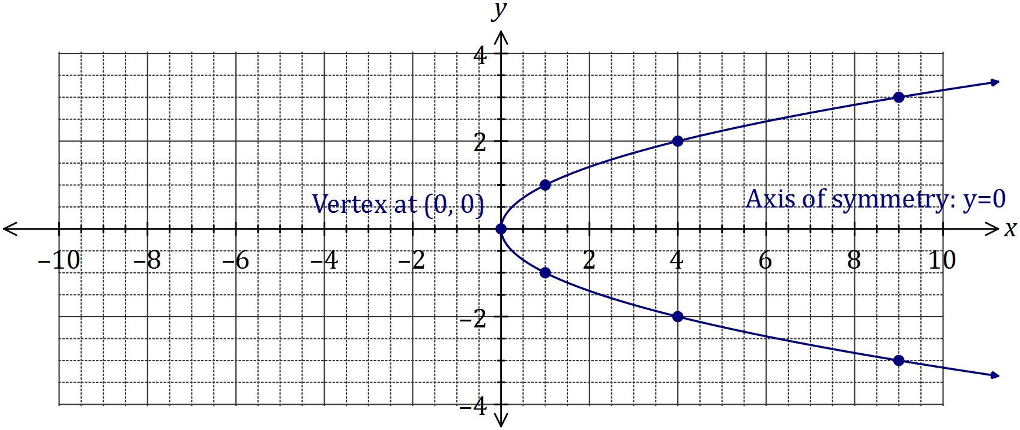
Solution
See graph
Specific behaviours
smooth curve through at least 5 out of 7 marked points
labels vertex
labels axis of symmetry

(b) Determine the equation of the circle shown below. (3 marks)

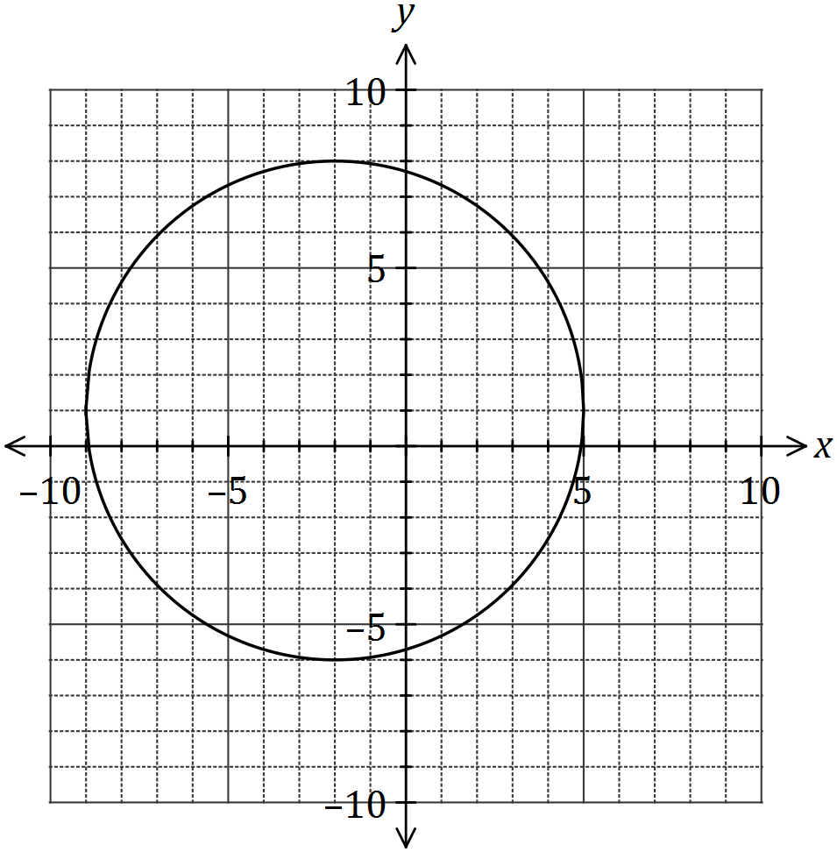
Solution
$${\left(x+2\right)}^{2}+{\left(y-1\right)}^{2}=49$$

Specific behaviours
uses standard form for circle
uses correct centre
uses correct radius

Question 2 (9 marks)
(a) The point $M(8, 1)$ is the midpoint of $A$ and $B(20, 7)$. Determine the coordinates of $A$.
(2 marks)
Solution
$$\frac{20+x}{2}=8 \text{and}\frac{7+y}{2}=1$$
$$x=-4, y=-5⇒ A(-4, -5)$$

Specific behaviours
writes equations
states coordinates of $A$

(b) A relationship between $x$ and $y$ is given by $x=2y-3$.

(i) Determine $y$ when $x=25$. (1 mark)
Solution
$$25=2y-3⇒y=14$$

Specific behaviours
states value

(ii) State, with justification, whether $x$ is a function of $y$. (2 marks)
Solution
Yes.
All values of the domain ($y$) are mapped to one value of the range ($x$).

Specific behaviours
states yes
reasoning includes one output for each input

(c) A straight line passes through points $C(2, -5)$ and $D(-2, 2)$. Determine the equation of the straight line that is perpendicular to this line and passes through $C$, expressing your answer in the form $ax+by+c=0$, where $a$, $b$ and $c$ are integers. (4 marks)
Solution
$$m_{CD}=-\frac{7}{4}⇒m_{⊥}=\frac{4}{7}$$
$$y-\left(-5\right)=\frac{4}{7}\left(x-2\right)⇒-4x+7y+43=0$$

Specific behaviours
determines gradient of CD
determines perp. Gradient
writes equation of line
writes equation in required form

Question 3 (7 marks)
Solve each of the following equations for the variable $x$.

(a)

Solution
Specific behaviours
moves 6 to other side
solves

(b)$3\left(1-x\right)+4=2(2x-7)$. (2 marks)
Solution
$$3-3x+4=4x-14 \\ 21=7x⇒x=3$$

Specific behaviours
expands
simplifies and solves

(c) $\frac{4}{x}$ $=3+x$. (3 marks)
Solution
$$4=3x+x^{2}⇒x^{2}+3x-4=0 \\ \left(x+4\right)\left(x-1\right)=0 \\ x=-4, x=1$$

Specific behaviours
equates to zero
factors
solves

Question 4 (8 marks)
(a) Solve the equation $x^{3}=7x^{2}+30x$. (4 marks)
Solution
$$x^{3}-7x^{2}-30x=0$$
$$x\left(x^{2}-7x-30\right)=0$$
$$x\left(x-10\right)\left(x+3\right)=0$$
$$x=0, x=10, x=-3$$

Specific behaviours
equates to zero
factors out $x$
factors quadratic
states all solutions

(b) The graph of $y=ax^{3}+bx^{2}+cx+d$ is shown below. Determine the values of the constants $a$, $b$, $c$ and $d$. (4 marks)

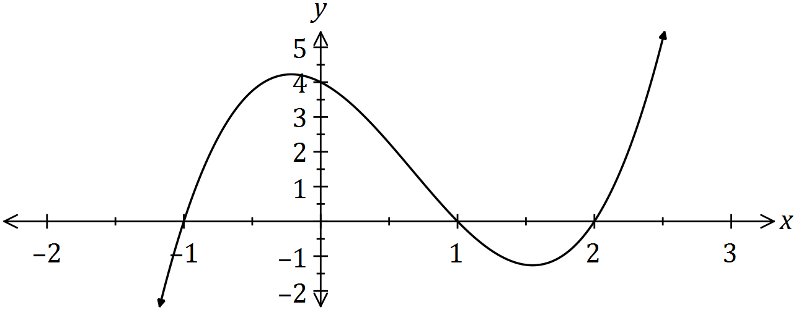
Solution
$$y=a\left(x+1\right)\left(x-1\right)\left(x-2\right)$$
$$x=0, y=4⇒4=2a, a=2$$
$$y=2\left(x^{2}-1\right)\left(x-2\right)=2\left(x^{3}-2x^{2}-x+2\right)$$
$$a=2, b=-4, c=-2, d=4$$

Specific behaviours
writes factors from roots
determines $a$
expands
states all values

Question 5 (6 marks)

Let
- Determine the new function if is translated 4 units to the right and 2 units up.
(2 marks)

Solution
Specific behaviours
use x -4
uses + 2

(b)Sketch the transformed function in (a) above on the axes below showing all features.
(4 marks)

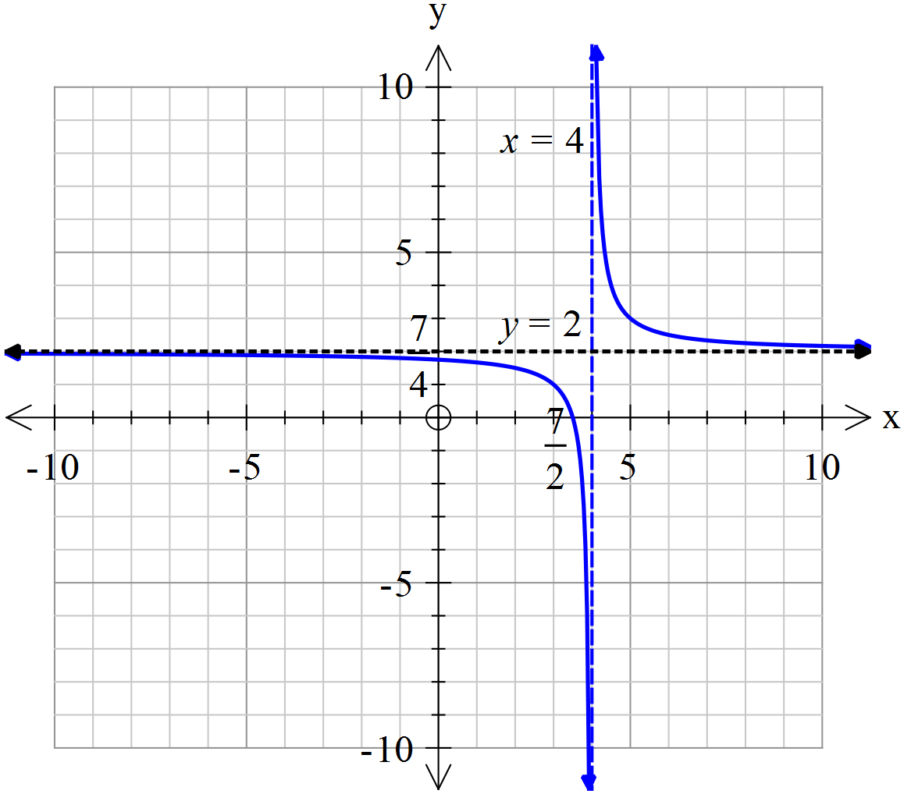

Solution
Specific behaviours
draws in horizontal asymptote and labels equation
draws in verticall asymptote and labels equation
states y intercept
states x intercept

Question 6 (8 marks)
(a) For the graph with equation $y=(x+1)(x-3)$, determine the coordinates of

(i) all axes intercepts. (2 marks)
Solution
$y$-intercept: $(0, -3)$. $x$-intercepts: $(-1, 0)$ and $(3, 0)$

Specific behaviours
$y$-intercept
$x$-intercepts and all answers written as coordinates

(ii) the turning point. (2 marks)
Solution
Line of symmetry: $x=1$
$y=\left(1+1\right)\left(1-3\right)=-4$
TP at $(1, -4)$
Specific behaviours
$x$-coordinate
turning point in coordinate form

(b) The graphs of three quadratic functions with discriminants of 0, 1 and -2 are shown below.

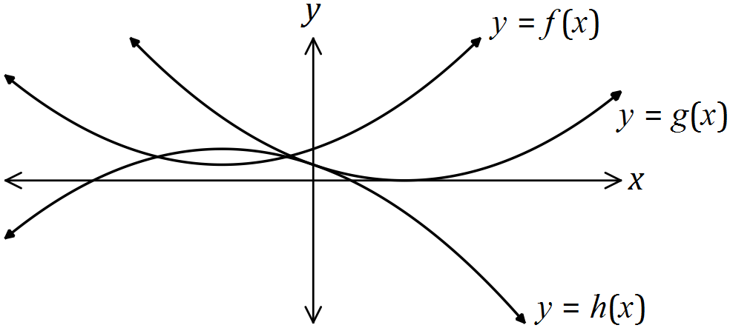
Solution (i)
see table

Specific behaviours
at least one correct
all correct

(i) Underneath each function in this table, write the value of it's discriminant.
(2 marks)
Function | $$f(x)$$ | $$g(x)$$ | $$h(x)$$
Discriminant | -2 | 0 | 1

(ii) Clearly explain your choices in part (i). (2 marks)
Solution (ii)
$f$ has no roots, $g$ has 1 root and $h$ has two roots. Discriminant is: -ve, no roots; 0, one root; and +ve, two roots.

Specific behaviours
states number of roots of each function
explains use of discriminant

Question 7 (8 marks)
(a) Divide the polynomial by (4 marks)

Solution (ii)
.
Specific behaviours
sets up table for long division
determines first term in quotient
determines complete quotient
has zero remainder

(b) Hence sketch showing x and y intercepts. ( 4 marks)

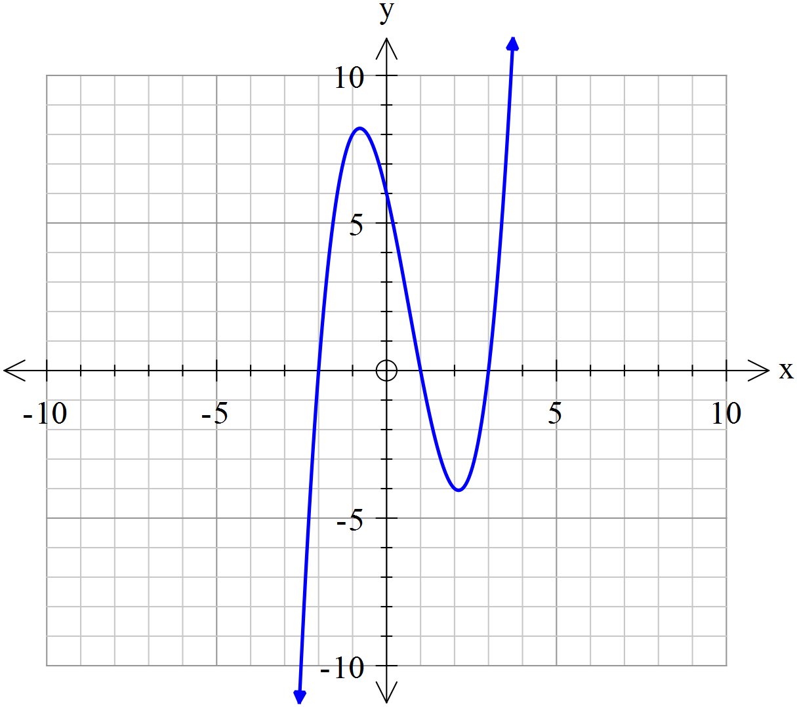

Solution (ii)
.
Specific behaviours
fully factorises to obtain three x intercepts
states y intercept
correct shape
local max and min placed in correct interval, though not drawn to scale

Additional working space

Question number: _________

© 2016 WA Exam Papers. Rossmoyne Senior High School has a non-exclusive licence to copy and communicate this paper for non-commercial, educational use within the school. No other copying, communication or use is permitted without the express written permission of WA Exam Papers. SN085-092-2.

